Ebook: Instructor Guidelines
OpenPage

Created June 29, 2017

Contents
Feature list for an Instructor 3
Manage Learning Groups 4
Annotation Sharing & Feeds 8
1. Annotation Feeds 8
2. Instructor Sharing a Single Annotation 9
3. Instructor Bulk Sharing Annotations 10
4. Save & Sync 10
Accessing Instructor Reports 11

Feature list for an Instructor
An OpenPage 2.0 user can play either the role of an Instructor or a learner for a Title. Depending on the role for that book title, the user will have different access to features.
User with Learner role will have access to all functionalities of the Reader:
  - View bookshelf showing list of subscribed books
  - Read a book
  - View Table of Contents
  - Search
  - View Glossary (inline & global)
  - View enrichments
  - Attempt quizzes
  - View / Create Bookmarks
  - View / Create annotations (notes, highlights, etc)
  - View Instructor annotations
  - Sync annotations
  - Join a learning group
  - Manage the learning groups you are part of
  - Manage learning Group
  - Share annotations with users of learning group

Note 1 - Learners cannot share annotation that they create with any other user. But they can view the annotations shared with them by Instructor.

Note 2 - An access key generated in OpenPage will either be for an instructor or learner. Depending on the access key which you redeem, you will be assigned a role (Instructor or Learner) for the title.

Manage Learning Groups

In OpenPage 2.0, instructors can create learning group, with learners and other instructors part of that group. Instructors who are part of the learning group can create annotation and share these with the learners of that group. This helps in collaborating on a book and also learners get access to real time inputs from instructor. Following are the salient characteristics of learning groups in OpenPage 2.0

- Only a user with a Instructor role can create groups [Note - A user can be instructor for a book and learner for another book]
- Group can have multiple Instructor and Learners
- A Instructor can be owner of several learning groups. A Learner can be part of several learning groups
- The learning groups are created on book level. So for each book we can have multiple learning groups created by instructors.

Step 1: A user with Instructor role type can create new group by clicking on “My Groups” option in book context button for assigned books.

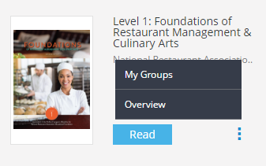

Step 2: The user will be re-directed to a new page for managing groups for the book. It will show the list of all groups the Instructor is owner of and number of subscribers in that group. The Instructor will also have option to edit or delete any group. Click on “Create Group” to create a new group

Step 3: The user will be re-directed to a pop up window where in the user needs to enter the group name. Click on Submit button to create the group.

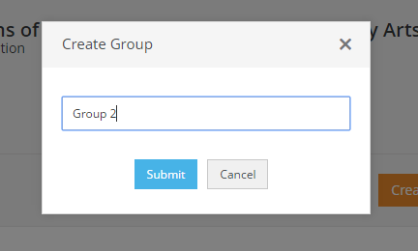

Once the group has been created, the user will be able to see the group name in the list. By clicking on Edit button the user can edit the name of the group. User will be able to see his/her name on the top with an icon of crown assigned to it since he/she is the owner of the group. The user can add members to the group by clicking on Add Members.

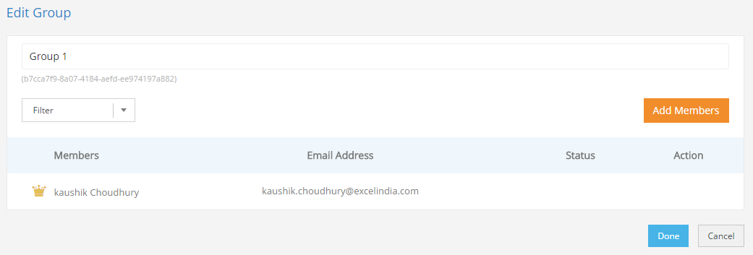

Step 4: Click on “Add Members”, provide an appropriate email id and click on add. Once you click on done, an invite will be sent to the respective user id.

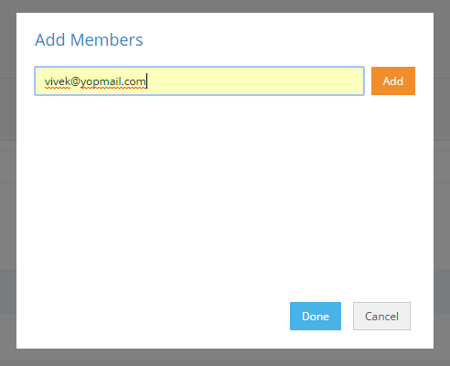

Step 5: An invite will be sent to the user, accepting which the user will be added to that respective group.

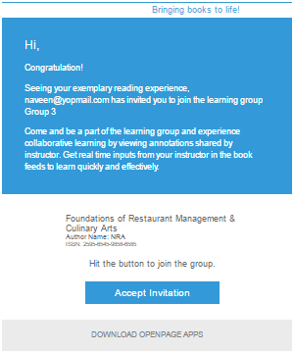

Step 5: The members selected in previous step will be shown under the group with status “Pending” until they accepts the invite sent on their email.

Step 6: Once the user accepts the email invite, he/she will be added to the respective group.

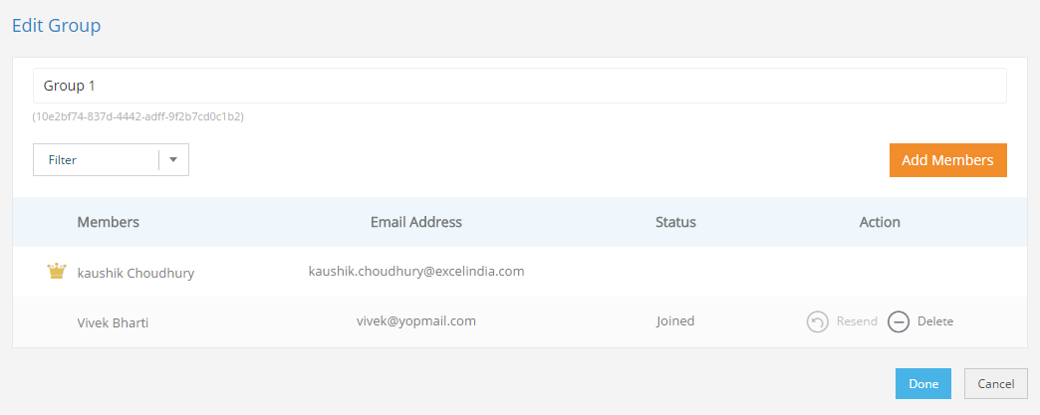

Note: In case a user has a Group Access code they can directly join a group by clicking on the “Have a group access code?” button. It will show a popup in which the user can enter the group access code and then submit which will then include them in the specific group.
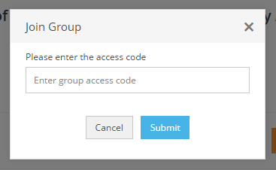

Annotation Sharing & Feeds

OpenPage 2.0 comes with a rich social framework, which facilitates a collaborative teaching and learning experience by allowing Instructors and Learners to share annotations. An Instructor type user can share all annotations (except highlights) with one or more groups of Learners. A group can have both Instructor and Learner type users.

Annotation Feeds

A “feed” is a listing of annotations. The user can view feeds by clicking on the icon the left menu.
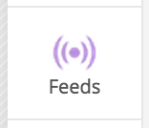
All feeds can be filtered by Chapter / Topic or by Annotation Type. Additionally, the user has the option of viewing annotations chronologically (most recent annotation on top), or by Table of Contents (in which each annotation will be slotted into a particular chapter / topic of the TOC).

For a Learner user, there are two feeds available:
- Instructor’s Feeds: Annotations shared by the Instructor with a group of which the Learner is a member.
- My Feeds: These are annotations that the Learner has created for personal consumption.

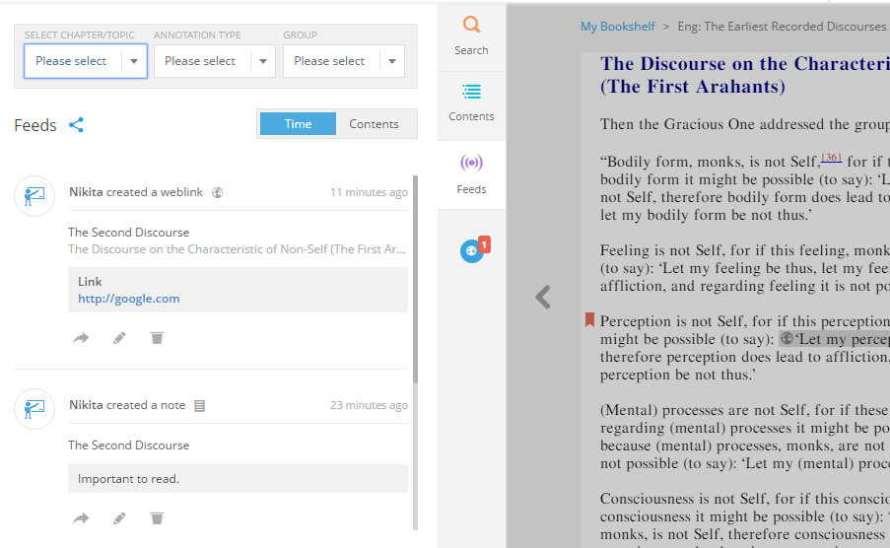

For each feed entry would display the following information: Creator of the annotation, Type of annotation, chapter/topic, created date-time.
The user will also have option to edit and delete the annotation from feed. Also, to jump to the annotation in the eBook.

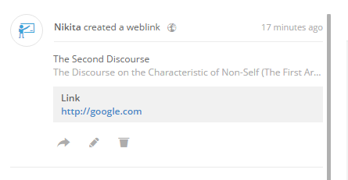

NOTE - for any annotation that the user is not an owner/creator, the Edit button is not provided. This is true for all feeds appearing in the Instructors’ Feed tab for a Learner.

Instructor Sharing a Single Annotation

At the time of creating annotations, user has to click on Add Groups icon to populate the list of groups created by him/her. The user can select single or multiple groups to share the annotations with. Selecting the required groups and clicking on save will share the annotations with group users.

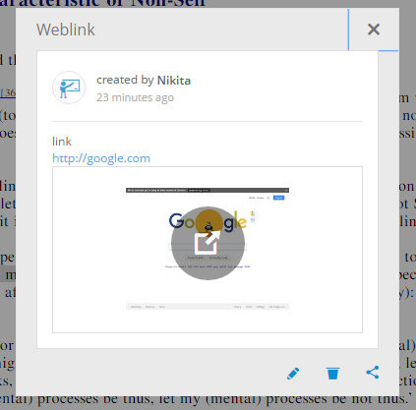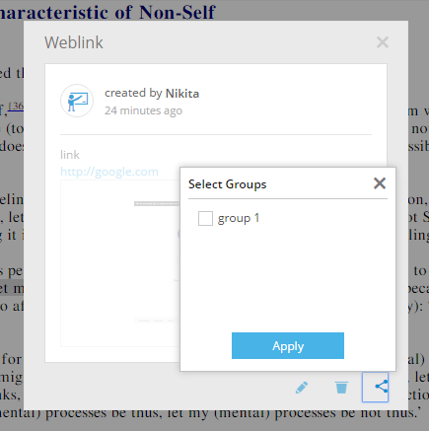

The shared annotation will appear in Feeds section as well for the user. To edit the note or to add/remove groups to which annotation is shared, user has to select the text on which annotation was created after which Edit and Delete options will appear.

Instructor Bulk Sharing Annotations

The Instructor type user will also have the feature available to share annotations with group of users in bulk. In the feeds section, clicking on the Sharing icon will open the bulk annotation-sharing window. On the page, all annotations created by user will be listed with their current sharing priorities. The option to filter out the annotations based on chapter/topic and type is also provided. User can select/deselect the groups for individual annotations or for all annotations.

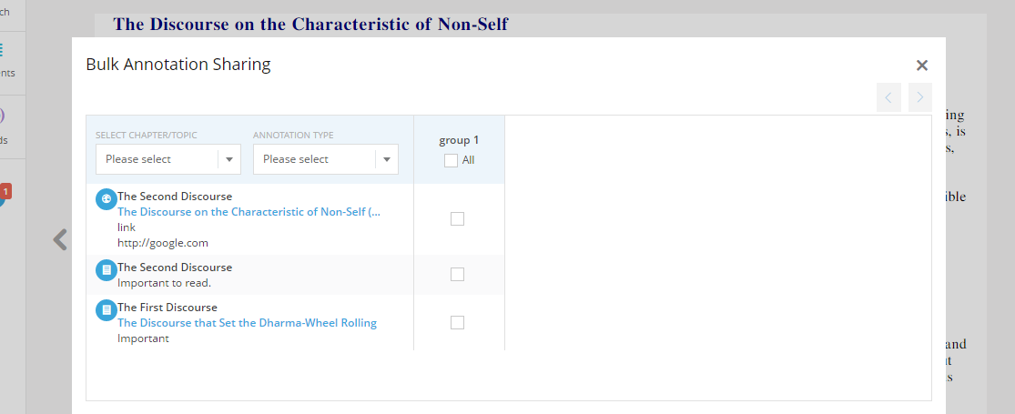

Save & Sync

The save & Sync feature will synchronize all the annotations, bookmarks and settings created by user with server. If the user does not have internet connectivity then an error message will be shown. This feature allows user to login to reader from any other computer or mobile devices and view only the updated content.
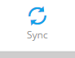

Accessing Instructor Reports
1. The instructor can access the Reports from the drop down menu as shown below:

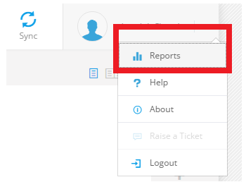

2. The instructor will be shown the Reports dashboard

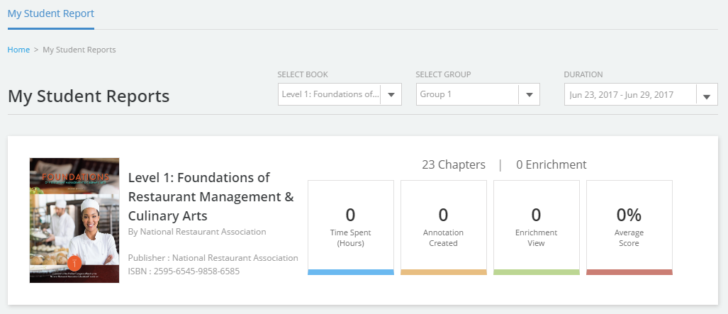

By accessing various parameters in the dashboard the Instructor would be able to do the following:

1. Select a book to view book specific reports
2. Select a group to view group specific reports
3. Select a timeframe to view reports for a specific time interval.
4. View the time spent on a book, group or in a specific time interval.
5. View the number of annotations created in a book, by a group or in a specific time interval.
6. View the number of enrichment viewed in a book, by a group or in a specific time interval.
7. The average score of assessments in a book, by a group or in a specific time interval.
8. View chapter-wise Class Performance
9. View Student-wise Class Performance
10. Student engagement to Performance Co-Relation

